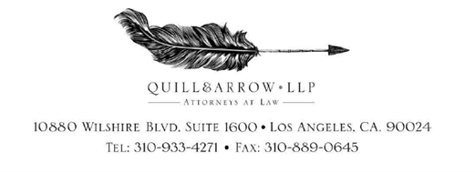

March 5, 2024
Via Certified-Mail

[Car Manufacture Address]

Re: Our Client: << Matter.CustomField.PlaintiffsNameShort >>
Vehicle Make/Model: << Matter.CustomField.VehicleYear >> << Matter.CustomField.VehicleMake >>
Vin: << Matter.CustomField.VinNumber >>

To whom this May Concern:

Please be advised that this firm has been retained by the above-named individual, concerning their purchase of a defective << Matter.CustomField.VehicleYear >> << Matter.CustomField.VehicleMake >>. Cease all further communications with our client regarding to this matter.

Direct all further correspondence to the following address:

Kevin Y. Jacobson, Esq.
e-service@quillarrowlaw.com
Quill & Arrow, LLP
10880 Wilshire Blvd., Suite 1600
Los Angeles, CA 90024

If you have any further questions or concerns, you can contact us at (310) 933-4271 or via fax at (310) 889-0645.

Sincerely,
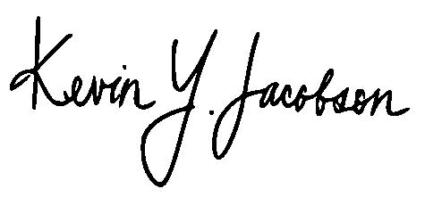
Quill & Arrow LLP

________________________
Kevin Y. Jacobson, Esq.

